한국어 제목
Novel Fluorescence-Based Heavy Metal Ion Detection System
Gildong Hong¹, Cheolsu Kim²
¹ ²Department of Chemistry, Sample University, 123 Science-ro, Seoul 12345, Republic of Korea

Abstract: The abstract should be written in English and be between 100 and 250 words. An ideal abstract concisely summarizes the entire paper in a single paragraph, covering the following elements in order: (1) the background and motivation for the research, (2) the objective or research question, (3) a brief description of the methods used, (4) the key results and findings, and (5) the conclusions and implications of the work. The abstract should be self-contained and understandable without reference to the main text. Avoid citing references, using undefined abbreviations, or including figures and tables. Write in the past tense for methods and results, and in the present tense for conclusions and general statements.
Key Words: Acid detection, Colorimetric reaction, Naked-eye detection

1. 서론 (Introduction)

The introduction should provide the necessary background and context for the study, guiding the reader from the broader field to the specific research question. Begin with a brief overview of the topic and its significance, followed by a critical review of relevant prior work, clearly identifying gaps or limitations in the existing literature. The section should conclude with a concise statement of the study's objective and, where appropriate, a summary of the approach taken. The introduction is typically 3–5 paragraphs in length and should be written in the present tense when referring to established knowledge and in the past tense when describing previous studies.

2. 연구 재료 및 방법 (Materials and Methods)

2.1 Materials
The methodology section should provide sufficient detail for the study to be reproduced by another researcher. Describe the materials, instruments, and experimental procedures used, organized in a logical and chronological order. Include the source and purity of all reagents, the specifications of key equipment, and the conditions under which experiments were conducted. Where applicable, describe any data processing, statistical methods, or computational tools employed. This section should be written in the past tense and in the passive voice. Do not include results or discussion in this section.

3. 결과 및 논의 (Conclusion)

3.1 Analysis
The results section should present the findings of the study in a clear and objective manner, without interpretation or speculation. Data should be reported accurately, supported by figures, tables, or spectra where appropriate. All figures and tables must be numbered sequentially and accompanied by descriptive captions. Refer to each figure or table explicitly within the text. Present results in a logical order that aligns with the sequence of methods described. This section should be written in the past tense. Statistical values, units, and significant figures must be reported consistently throughout.

5. References

[1] references should be in MLA format
[2] references should be numbered in correct order

+Authors are free to adjust the content within each section to suit their research.

+figure example
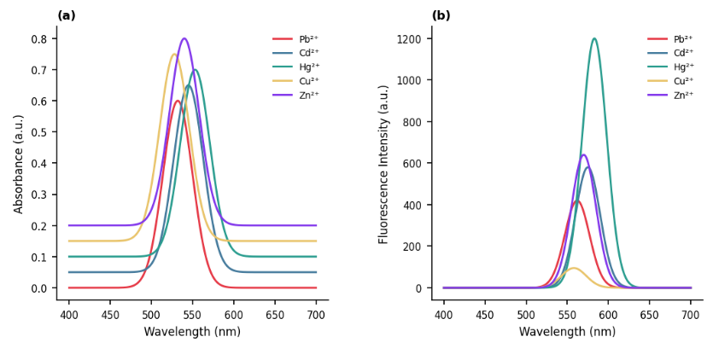
[Fig. 1] The figure title should be in this font.
(a) Photograph of solution containing Cu(NO3)2·3H2O and
Mn(CH3COOH)2·4H2O (b) Photograph of CuMn2O4 gel

